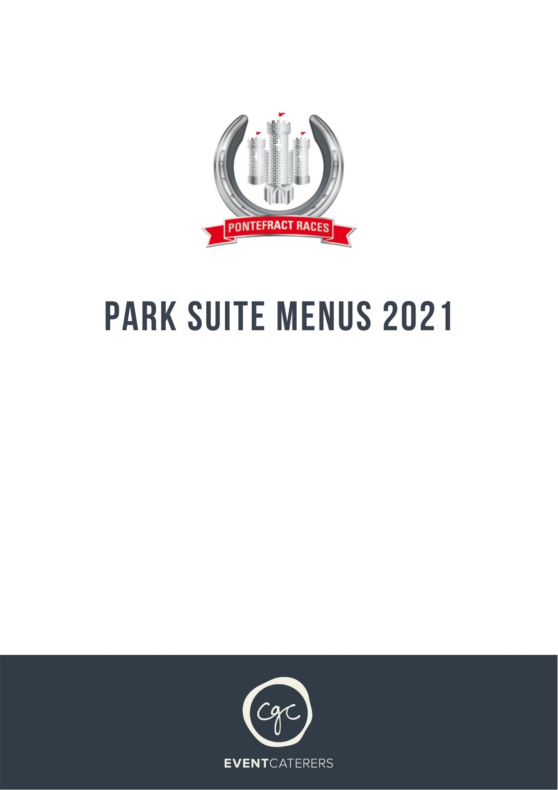
PARK SUITE MENU ONE
To include morning coffee and biscuits on arrival, the menu shown below and light afternoon tea (replaced by canapes and bites on arrival for evening meetings)

Seafood selection to start
Smoked salmon, tiger prawn and avocado terrine with herb salad and dill dressing

Vegetarian alternative
Warm roasted butternut squash and gruyère tart,
rocket and toasted pumpkin seed salad

Hot carvery selection from the buffet
Roast sirloin of beef
Roast loin of pork with apple sauce and seasoning

Roast and buttered new potatoes
Cauliflower cheese
Spring greens
Petit pois and whole baby carrots

Vegetarian and fish dish of the day – on request
Smoked goats cheese gateau with roasted Tuscan vegetables,
crushed herb new potatoes, sweet pepper compote (gf)

Roast cod fillet,
Mediterranean vegetables, puy lentils, lemon and dill cream sauce (gf)

Ground coffee, Yorkshire tea and chocolate mints served to the table

Trio of desserts
Dark chocolate and amaretto terrine
Sugar glazed lemon tart
Baked vanilla cheesecake

Ground coffee, Yorkshire tea and chocolate mints served to the table

PARK SUITE MENU TWO -
To include morning coffee and biscuits on arrival, the menu shown below and Light afternoon tea (replaced by canapes on arrival for evening meetings)

Seafood buffet selection to start
Smoked salmon, tiger prawn and avocado terrine with herb salad and dill dressing

Vegetarian alternative
Roasted red pepper, heritage tomato and vegan mozzarella caprese salad,
torn rocket, toasted pine nuts and roasted garlic pesto dressing (vg)

Hot carvery selection from the buffet
Roast sirloin of beef
Roast loin of pork with apple sauce and seasoning

Roast and buttered new potatoes
Cauliflower cheese
Spring greens
Petit pois and whole baby carrots

Vegetarian and fish dish of the day – on request
Pearl barley risotto, roasted butternut squash, asparagus, parmesan and pine nut pesto (v)

Smoked haddock,
crushed new potato hash, free range poached egg, tomato hollandaise

Trio of desserts
Dark chocolate and amaretto terrine
Sugar glazed lemon tart
Baked vanilla cheesecake

A selection of three local cheeses,
chutney, celery, grapes and biscuits

Ground coffee, Yorkshire tea and chocolate mints served to the table

